MILADA PRIVORA

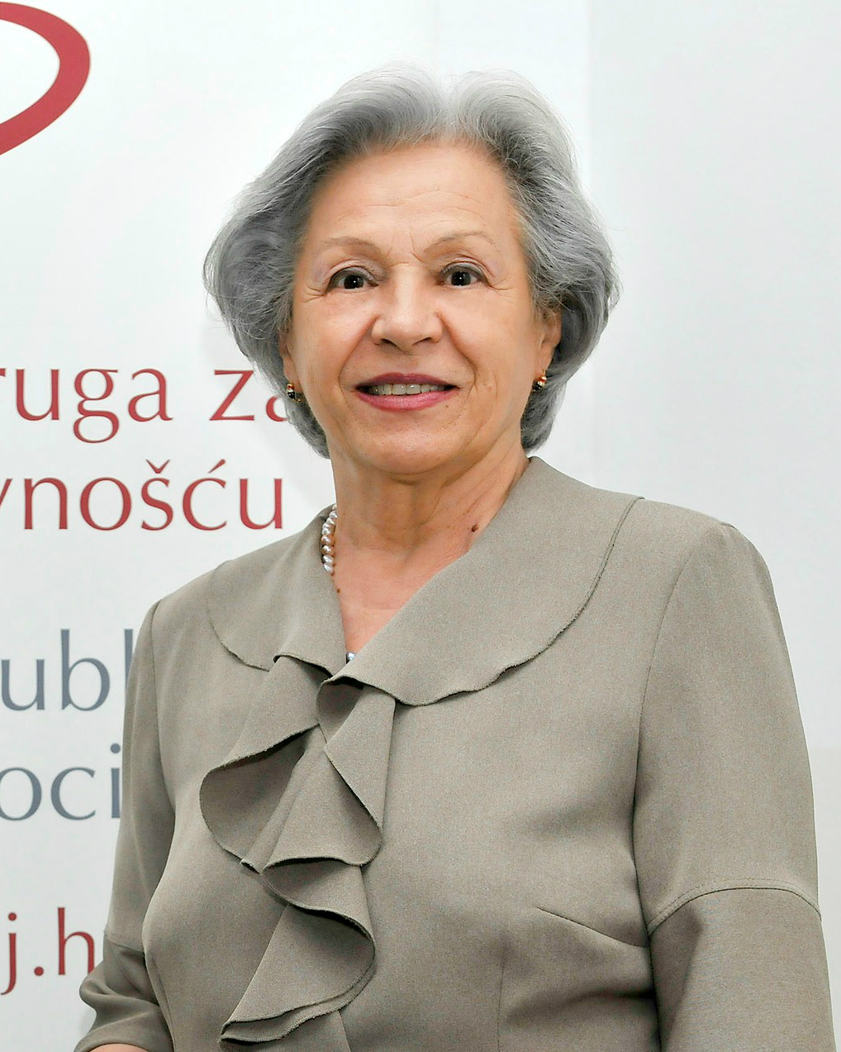
Milada Privora was a longtime Chief of Protocol. She started working in the field of public relations in Office for Protocol, Public Relations and Promotions in 1984. in Zagreb construction company, Industrogradnja. She held that position until 1994 when she was appointed as Deputy Head of State Protocol of the Republic of Croatia. By the decision of the President of the Republic of Croatia in 2000., Milada Privora was appointed Head of State Protocol and Ambassador, and Chief of President's Protocol. She held that possition until her retirement in 2004.
She graduated from Faculty of Architecture in Zagreb and later, from Diplomatic Academy in 1996. She has been a lecturer at Defence Diplomacy Course at „Petar Zrinski“ Croatian Defence Academy (today „Dr. Franjo Tuđman“), „Ban Josip Jelačić“ War School, London School of Public Relations, Faculty of Humanities and Social Sciences, Centre for Post-graduate studies, Department of Conference Interpreting and an External Associate for Protocol at Croatian Academy of Arts and Sciences. On top of that, she is also a guest lecturer at Faculty of Political Sciences.
Primarily, since 2009 she is a professor of Diplomatic Protocol at Dag Hammarskjöld University College of International Relations and Diplomacy and withal a consultant for protocol and public relations for many international companies.

