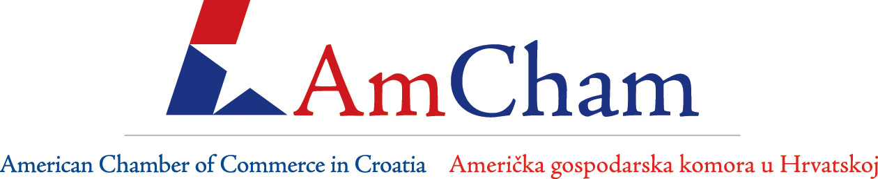

CONFIRMATION FORM FOR AMCHAM
MEMBER-TO-MEMBER DISCOUNT PROGRAM

Thank you for participating in the AmCham Member-to-Member Discount Program. Your company’s involvement in this exciting promotional opportunity adds to the prestige of both the Discount program and your organization. We trust that your organization will gain new and valuable clients and customers as well as increase the company’s profile through this program. Please ensure the following information about your organization and the discounts you offer to Members is correct and confirm your participation in the Program by signing below and e-mail back to us. If you have any additional questions, please feel free to contact us directly.

IMPORTANT NOTES:

Company:
Contact: |  | Title:
Address: |  | Phone:
Fax: |  | E-mail:
Website:

DISCOUNT AMOUNT & DESCRIPTION:

Please send us one Photo (high quality) related to the offer, attached to the e-mail confirmation!

Signature of Company Representative Title Date

